National University of Computer and Emerging Sciences
Lab Manual
Computer Organization and Assembly Language

Lab 10
Instructor Wajahat Ali Khan
Class lab 4, lab 8
Semester Fall 2022
Fast School of Computing
FAST-NU, Lahore, Pakistan

Objectives
- Hardware/Software Interrupts
- Graphics Mode
- Video Memory
- Design 2D Graphics
Contents
Objectives 2
ACTIVITY 1: [50 Marks] 2
ACTIVITY 2: [50 Marks] Error! Bookmark not defined.
REFERENCES 3
Note for all questions: You can make as many memory variables, subroutines as you need. Must read all the manual before starting.

ACTIVITY 1: [50 Marks]
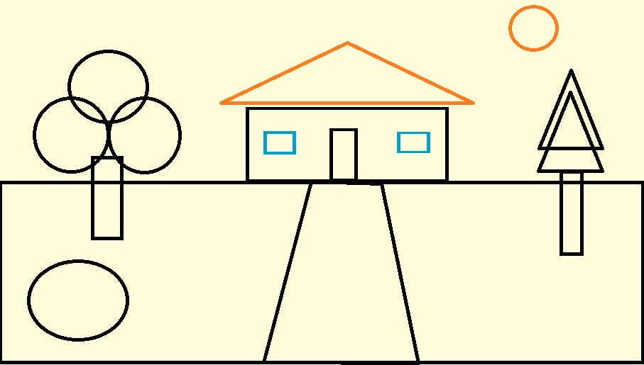
In the previous lab, you have used int 10h for graphics displaying a Diamond using AX = 0x000D service which extended your graphic resolution to 320 X 200. This lab is using AX = 0x0010 service which extended your graphic resolution to 640 X 350.
Write a comprehensive program which:
- Generates an animation for the line drawing shown in the attached picture.
- Your program should start working on the animation after you press any key from the keyboard.
- Once the animation is finished you should your program should wait for key press before moving forward.
- Circle drawing programs are given to you, for printing
[hint]
Use the Circle Drawing program in the Appendix. For more information about the graphics mode please refer to [1] and Chapter 12 of textbook.

REFERENCES
- http://vitaly_filatov.tripod.com/ng/asm/asm_023.1.html
- http://www.dosbox.com/download.php?main=1
- http://sourceforge.net/projects/nasm
- http://www.nasm.us/
- http://www.programmersheaven.com/download/21643/download.aspx (AFD)

Appendix
; circle in graphics mode
[org 0x0100] jmp start
; coordinates of a circle of radius 24 x24: dw 48,47,44,40,36,30,24,17,12,7,3,0,0,0,3,7,11,17,23,30,36,40,44,47,48 y24: dw 24,30,36,40,44,47,48,47,44,40,36,30,24,17,11,7,3,0,0,0,3,7,11,17,23
; coordinates of a circle of radius 45 x45: dw
90,89,88,86,83,79,75,70,64,58,52,46,40,34,28,22,17,12,8,5,2,0,0,0,0,2,5,8,12,17,22,28,34,40,46,52,58,6
4,70,75,79,83,86,88,89,90 y45: dw
45,51,57,63,68,73,78,82,85,87,89,89,89,88,86,83,80,76,71,66,60,54,48,41,35,29,23,18,13,9,6,3,1,0,0,0,2 ,4,7,11,16,21,26,32,38,44
; coordinates of a circle of radius 72 x72: dw
144,143,142,141,139,137,134,130,127,122,118,113,108,102,96,90,84,78,72,65,59,53,47,41,36,30,25,21,
16,13,9,6,4,2,1,0,0,0,1,2,4,6,9,13,16,21,25,30,35,41,47,53,59,65,71,78,84,90,96,102,108,113,118,122,12
7,130,134,137,139,141,142,143,144 y72: dw
72,78,84,90,96,102,108,113,118,122,127,130,134,137,139,141,142,143,144,143,142,141,139,137,134,1
30,127,122,118,113,108,102,96,90,84,78,72,65,59,53,47,41,35,30,25,21,16,13,9,6,4,2,1,0,0,0,1,2,4,6,9,1 3,16,21,25,30,35,41,47,53,59,65,71 ; coordinates of a circle of radius 120 x120: dw
240,239,239,238,237,235,234,232,229,226,223,220,217,213,209,204,200,195,190,185,180,174,168,163,
157,151,144,138,132,126,120,113,107,101,95,88,82,76,71,65,60,54,49,44,39,35,30,26,22,19,16,13,10,7,
5,4,2,1,0,0,0,0,0,1,2,4,5,7,10,13,16,19,22,26,30,35,39,44,49,54,59,65,71,76,82,88,95,101,107,113,119,1
26,132,138,144,151,157,163,168,174,180,185,190,195,200,204,209,213,217,220,223,226,229,232,234,2
35,237,238,239,239,240 y120: dw
120,126,132,138,144,151,157,163,168,174,180,185,190,195,200,204,209,213,217,220,223,226,229,232,
234,235,237,238,239,239,240,239,239,238,237,235,234,232,229,226,223,220,217,213,209,204,200,195,
190,185,180,174,168,163,157,151,144,138,132,126,120,113,107,101,95,88,82,76,71,65,59,54,49,44,39,
35,30,26,22,19,16,13,10,7,5,4,2,1,0,0,0,0,0,1,2,4,5,7,10,13,16,19,22,26,30,35,39,44,49,54,59,65,71,76,8 2,88,95,101,107,113,119
; setting up the parameters

counter : db 0; radius : equ 120 ; choose radius (24, 45, 72, 120) xoffset: equ 0 ; change to move circle along x axis yoffset: equ 0 ; change to move circle along y axis
start:
mov si, x120 ; change x array as radius mov di, y120 ; change y array as radius
mov ax, 0x0010 ; set 640 x 350 graphics mode
int 0x10 ; bios video services mov ax, 0x0C07 ; put pixel in white color xor bx, bx ; page number 0 mov cx, [si] ; first x position
add cx, xoffset ; moving point along x axis mov dx, [di] ; first y position add dx, yoffset ; moving point along y axis l1:
int 0x10 ; bios video services add si, 2 ; next location address add di, 2 ; next location address mov cx, [si] add cx, xoffset mov dx, [di] add dx, yoffset inc byte[counter]
cmp byte[counter], radius ; stopping condition jle l1 ; jump if less mov ah, 0 ; service 0 – get keystroke int 0x16 ; bios keyboard services mov ax, 0x0003 ; 80x25 text mode int 0x10 ; bios video services mov ax, 0x4c00 ; terminate program int 0x21

